PCB Design

For now don’t make any connections, just place these components on a wide PCB so we can see how much space it takes up and get approval from my potential customers.

4 stereo jacks (see picture at bottom and attached project file)

3 DB9 Female

1 DB9 male



2 RJ11 next to each other and 1 ethernet like this

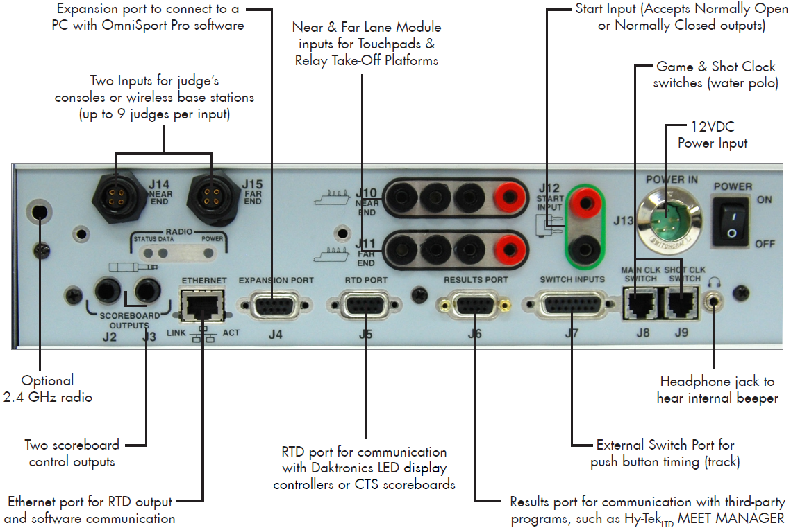

I will share the PCB files for this one that has the connector model numbers for the DB9 and stereo jacks.

